**Introduction**

Are you concerned about the rising living cost in Singapore? The over-crowded MRT trains? The difficulty to find jobs due to competitions from foreign talents? Or the dilution of the Singapore identity and culture? If yes, you are not alone. Many Singaporeans share the same worries as you do. You may have sensed that during your casual conversations with your family members, your friends and colleagues, or random encounters on the Internet. But your everyday social circle is limited and it may not allow you to fully know what is going on in your fellow citizens’ minds. Do you want to know how other Singaporeans think about these problems and whether they agree with you? Do you like to talk to these fellow Singaporeans directly and discover why they hold different views from what you do? And eventually after knowing what others think, do you wish to have a voice in shaping governmental policies regarding these issues? Our research project is set to fulfill these possibilities, through building a digital platform that will be open to a group of Singaporeans who come from all walks of lives and allow them to discuss these issues with each other.

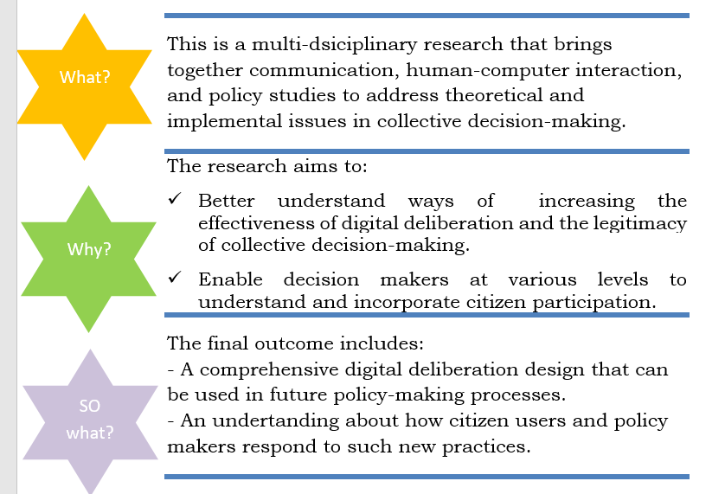

How it worked

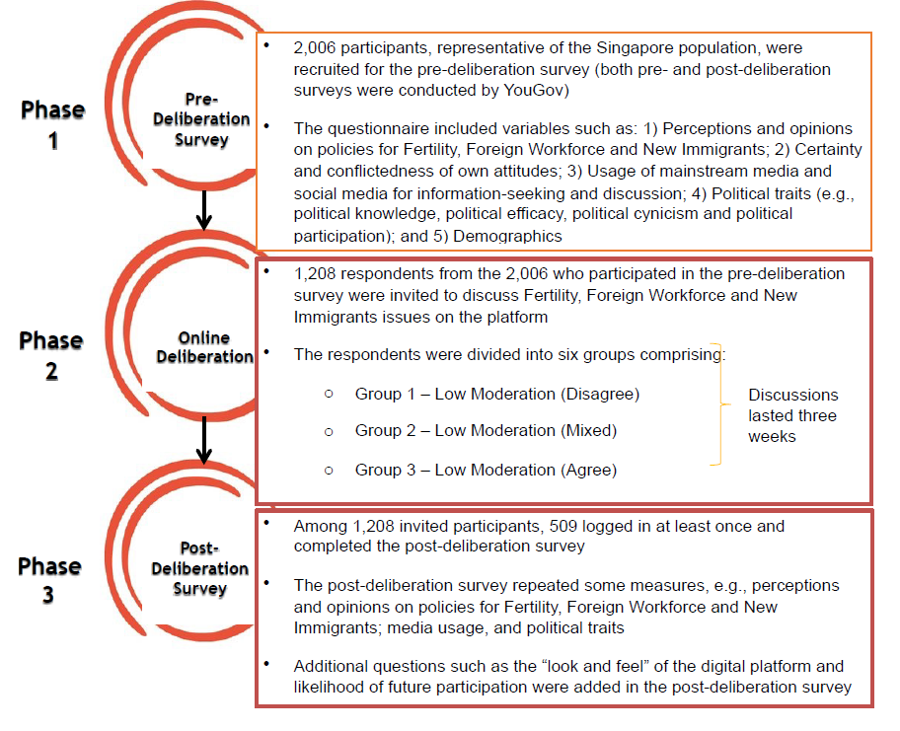

What the experience was like

Now you probably wonder how the digital platform actually “looks and feels”, should you be able to have the chance to participate. We had a few technological features built into the digital platform that you may find interesting.

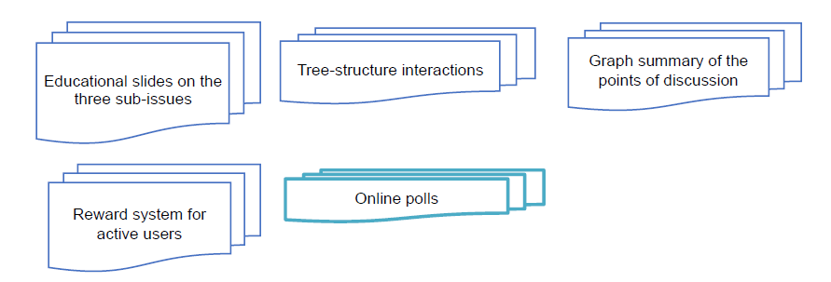

See more details in this Report on Preliminary Findings.

**Collaborators**

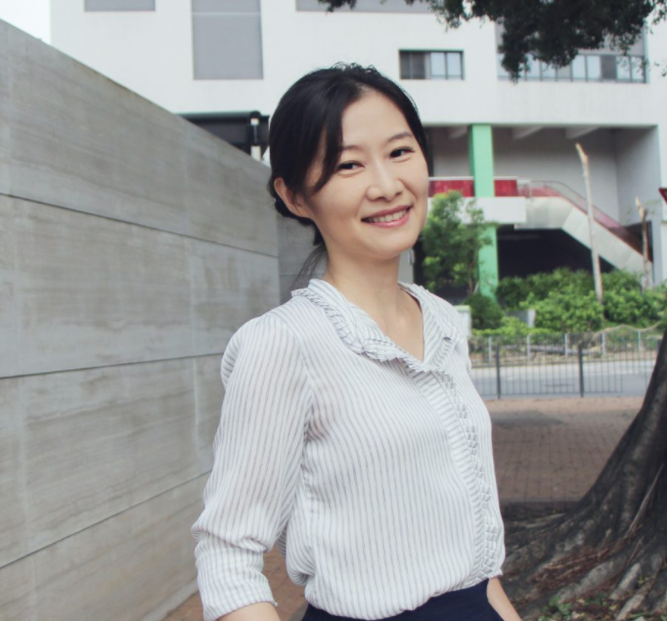

Dr. [Leanne Chang](http://www.coms.hkbu.edu.hk/faculty-staff/faculty/leannechang/)

Associate Professor, Hong Kong Baptist University



[Dr. Carol Soon](https://lkyspp.nus.edu.sg/ips/about-us/staff-directory/soon-carol)

Senior Research Fellow, Institute of Policy Studies, NUS

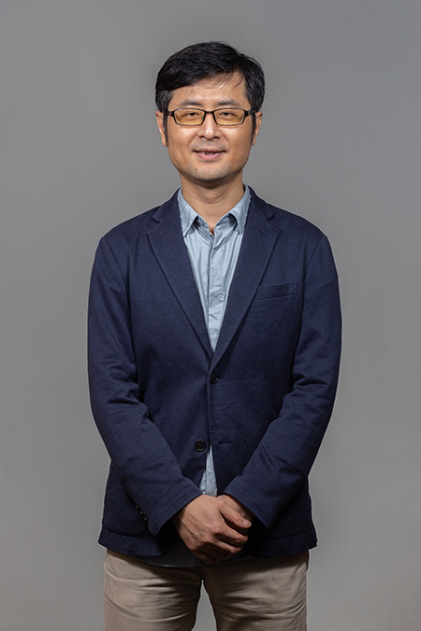

Dr. [Shengdong Zhao](https://shengdongzhao.com/newSite/)

Associate Professor, School of Computing, NUS



[**Dr. Simon Perrault**](https://istd.sutd.edu.sg/people/faculty/simon-perrault#biography)

**Postdoc Researcher**

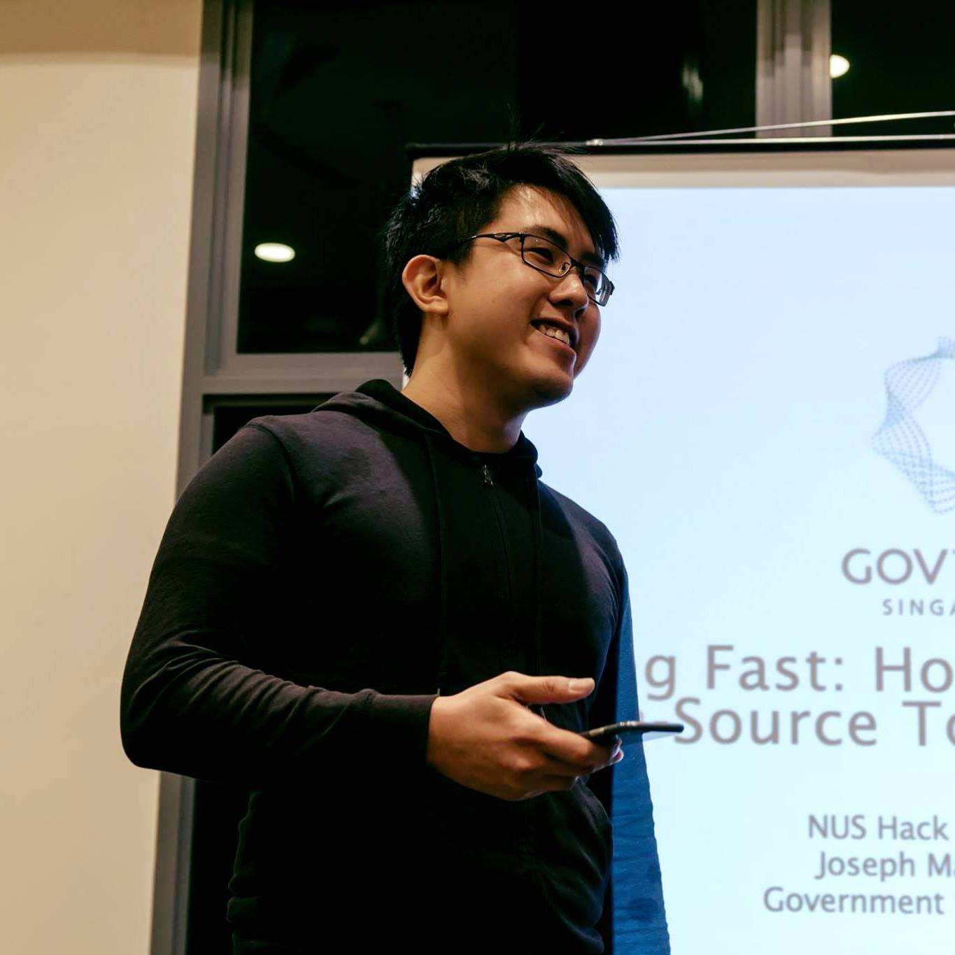

## **Joseph Matthias Goh**

Design Researcher



Jeffrey Effendy

Design Researcher



[Samson Tan](https://www.linkedin.com/in/samsontmr/)

Data Scientist



[Sanju Menon](https://www.linkedin.com/in/sanjumenonp/)

Research Assistant

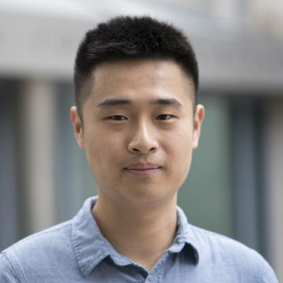

[Tian Yang](https://www.asc.upenn.edu/people/graduate-student/tian-yang)

Research Assistant

Yang Wang

Research Assistant

Jingjing Liang

Research Assistant

Naditha Das

Research Assistant

Chengting Mao

Research Assistant

Sabrina Mercy Anthony

Research Assistant

Andrea Nehl Parinas Caliwag

Research Assistant

**Events**

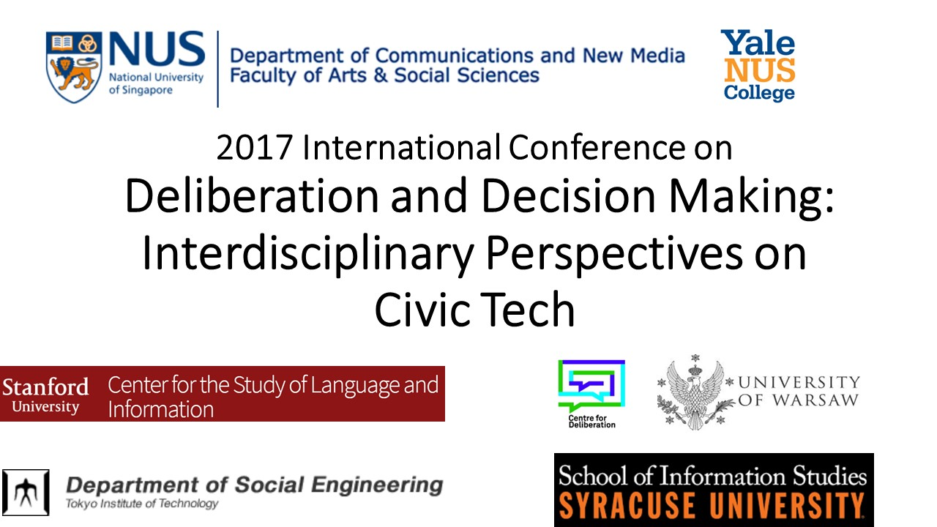

**Deliberation and Decision Making (DDM2017): An Interdisciplinary Conference on Civic Tech**

**The conference led to the publication of a symposium “**[**Online Deliberation and #CivicTech**](https://delibdemjournal.org/article/id/988/)**” featured in the Journal of Deliberative Democracy.**

**Publications**

1. Zhang W., Yang, T., & Perrault, S. (2021, May). [Nudge for reflection: More than Just a Channel to Political Knowledge](https://www.weiyuzhang.net/uploads/2/2/2/7/222747/chi2021-draft-camera-ready-final-highlighted.pdf). In *Proceedings of the SIGCHI Conference Full Papers on Human Factors in Computing Systems (CHI '21)*. ACM. [slides]
2. Zhang W. & Davies T. & Przybylska A., (2021). [Online Deliberation and #CivicTech: A Symposium](https://delibdemjournal.org/article/id/988/). *Journal of Deliberative Democracy, 17*(1), 76-77.
3. Chang L. & Zhang W., (2021). [Procedural Justice in Online Deliberation: Theoretical Explanations and Empirical Findings](https://delibdemjournal.org/article/id/968/). *Journal of Deliberative Democracy, 17*(1), 105-117. [slides]
4. Yang T. & Wang Y. & Zhang W., (2021). [Effects of Knowledge and Reflection in Intrapersonal Deliberation](https://delibdemjournal.org/article/id/964/). *Journal of Deliberative Democracy, 17*(1), 134-148. [slides]
5. Chen, Z & Zhang, W. (2020), [Bracketing or Reinforcing?: Socio-economic Status, Network Power, and Online Deliberation](https://www.sciencedirect.com/science/article/abs/pii/S0736585320300769). *Telematics & Informatics,* 52, Article 101417. [slides]
6. Zhang, W., Xi, Y., & Chen, A. (2020). [Why do replies appear? A multi-level event history analysis of online policy discussions](https://www.weiyuzhang.net/uploads/2/2/2/7/222747/nms880520_rev2_wz.pdf). *New Media & Society, 22* (8), 1484-1504. [slides]
7. Menon, S., Zhang, W. & Perrault, S. (2020). [Nudge for Deliberativeness: How Interface Features Influence Online Discourses.](https://arxiv.org/ftp/arxiv/papers/2001/2001.04612.pdf) In *Proceedings of the SIGCHI Conference Full Papers on Human Factors in Computing Systems (CHI ’20)*. ACM. [slides]
8. Zhang, W. & Yang, T. (2020). [The interaction between perceived procedural fairness and perceived disagreement in deliberation](https://link.springer.com/article/10.1057/s41269-018-0112-2). *Acta Politica, 55*, 199–220. [slides]
9. Perrault, S. & Zhang, W. (2019). [Effects of Moderation and Opinion Heterogeneity on Attitude towards the Online Deliberation Process..](https://arxiv.org/abs/1901.10720)In *Proceedings of the SIGCHI Conference Full Papers on Human Factors in Computing Systems (CHI '19).* ACM. [slides]
10. Zhang, W., & Soon, C (2017). [The Main and Spillover Effects of Online Deliberation: Changes in opinions, informational media use and political activities](http://onlinedeliberation.org/wp-content/uploads/2016/10/CeDEM2017_weiyu-and-carol-CS.pdf). In *Proceedings of CeDEM 2017*, Danube University Krems, Austria. [slides]
11. Zhang, W. (2015). [Perceived procedural fairness in deliberation: Predictors and effects](https://www.weiyuzhang.net/uploads/2/2/2/7/222747/proof_procedural_fairness_in_deliberation.pdf). *Communication Research*. 42(3), 345-364. [slides]
12. Zhang, W. (2015). The disenfranchised and eDeliberation: Beyond access. In Coleman, S., Przybylska, A., & Sintomer, Y. (Eds.), *Deliberation and Democracy: Innovative Processes and Institutions*, pp. 57-82. Frankfurt, Germany: Peter Lang.
13. Lu, X., Zhang, W., Przybylska, A, De Liddo, A., Convertino, G., Davies, T., & Klein, M. (2015). [Design for Online Deliberative Processes and Technologies: Towards a Multidisciplinary Research Agenda](http://onlinedeliberation.org/wp-content/uploads/assets/SIGCHI2015_online%20deliberation_final.pdf). In *Proceedings of CHI 2015 (Workshop)*, Seoul, South Korea.
14. Menon, S. & Zhang, W. (2014). [A value-based design approach for online deliberation](http://onlinedeliberation.org/wp-content/uploads/assets/CeDEM2014.pdf). In M. M. Skoric, P. Parycek, & M. Sachs (Eds.), In *Proceedings of CeDEM Asia 2014*, pp.81-96. Hong Kong, China.
15. Zhang, W. & Chang, L. (2014). [Perceived Speech Conditions and Disagreement of Everyday Talk: A Proceduralist Perspective of Citizen Deliberation](https://www.weiyuzhang.net/uploads/2/2/2/7/222747/perceived_speech_conditions_of_everyday_talk_r3.doc).*Communication Theory, 24*(2), 124-145. [slides]
16. Chang, L., Jacobson, T., & Zhang, W. (2013). [A Communicative Action Approach to Evaluating Citizen Support for a Government’s Smoking Policies](https://www.weiyuzhang.net/uploads/2/2/2/7/222747/joc_round3.pdf)*. Journal of Communication, 63*(6), 1153-1174. [slides]
17. Zhang, W., Cao, X., & Trah, M. N. (2013). [The structural features and the deliberative quality of online discussions](https://www.weiyuzhang.net/uploads/2/2/2/7/222747/structural_features_and_deliberative_quality_uploaded.pdf). *Telematics & Informatics, 30*(2), 74-86. [slides]
18. Zhang, W. (2010). [Technical capital and participatory inequality in eDeliberation: An actor-network analysis](https://www.weiyuzhang.net/uploads/2/2/2/7/222747/technical_capital_and_online_deliberation.pdf). *Information, Communication & Society, 13*(7), 1019-1039. [slides]

**Tools**

1. Platform Demo
2. Graph Editor Demo

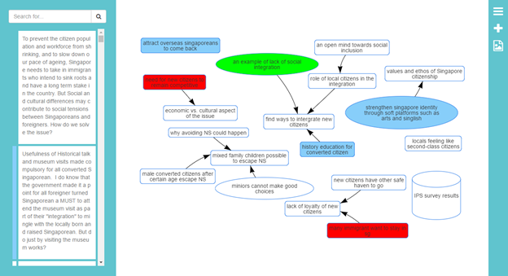

1. Policy Maker Interface Demo

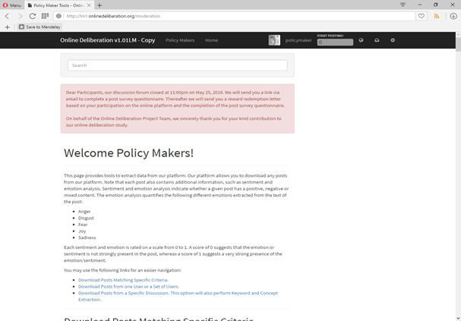

1. Sentiment Analysis Demo

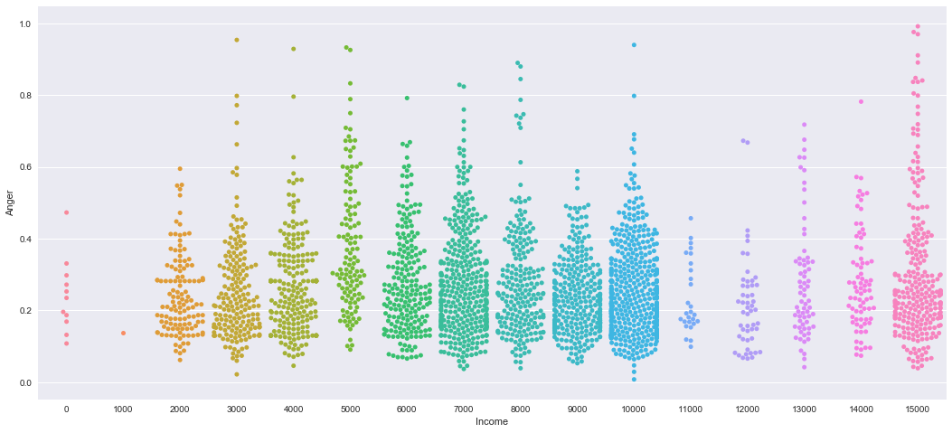

**Partner Institutions**

This research was funded by Singapore’s Ministry of Education Tier 2 grant (MOE2013-T2-1-105). Any opinions, findings and conclusions or recommendations expressed on this website are those of the authors and do not necessarily reflect the views of the funder.

Singapore’s Ministry of Education

NUS CHI lab

Institute of Policy Studies

# **NATIONAL POPULATION AND TALENT DIVISION**